Louth Hockey Club

PRIVACY NOTICE FOR OUR JUNIOR MEMBERS
We at the Louth Hockey Club want to make sure all the personal details we hold about you are safe and secure, so we have put together this note to tell all of our junior members, whether you are a player/participant or simply a fan of the sport, how we make sure we just do that and what to do in case you have any questions for us or want to see what information we have. We are, what is known as, a data controller. This means we have control over how your details are used and who we pass them to.
Sometime organisations like ours need to appoint an individual called a “Data Protection Officer” to make sure that we are being very careful with your information. Our Data Protection Officer is called Amie Wright.
what type of details do we collect from you?
We might collect the following personal details about you during before, during or after your time as a member, such as:
  - details of how we can contact you, such as your name, email address, where you live and phone number;
  - your birthday;
  - your gender;
  - membership details including when you signed up to be a member and any date you decide to leave us;
  - all records of when you contacted us or we contacted you on the phone or by email or when you asked us to do something;
  - any bank details belonging to your parent or guardian so that we can receive payments from you and details of any payments you make;
  - [how you use our website and any passwords, user names and other things that may identify you to us online;]
  - any images we capture on CCTV cameras and other information showing us your movements through our buildings, [for example where you have to use any swipecards or key fobs to get into certain parts of our buildings];
  - records that tell us when you were at our events or competitions;
  - videos and photos of you;
  - your hobbies, likes and dislikes so that we know what type of marketing we can send you;
  - your passport or other ID cards;
  - records of whether you play at a county/national level;
  - details of family members, coaches and other people we might need to contact in case of an emergency;
  - records of your rankings, gradings or ratings, including any competition results, what [events/matches/games] you have attended and how well you are performing on any development programme you are registered to;
  - any disciplinary information or details of any issues you have us or we have with you.
- SPECIAL CATEGORIES OF PERSONAL INFORMATION
We may also hold and use what is called “special information” such as your colour, background and which part of the world you or your family members are originally from, whether you have any religious beliefs and any information about your health such as any injuries you have/have had or times you may not have been very well. We will only use it if we have a really good reason to do so such as:
  - if it is in the interests of the public and we have a lawful reason to use it;
  - we need it to help us with a legal case we are involved in;
  - certain laws allow us to use it; or
  - you have told us you are happy for us to use it.
In the table below we refer to these as the “special reasons”.
- WHERE DO WE GET THIS INFORMATION FROM?
We will normally collect personal information about you when you create an account on our site at www.louthhockeyclub.co.uk to become a member of Louth Hockey Club, or when you want to talk to us on the phone, by e-mail or in some other way.

- how do we use your information?
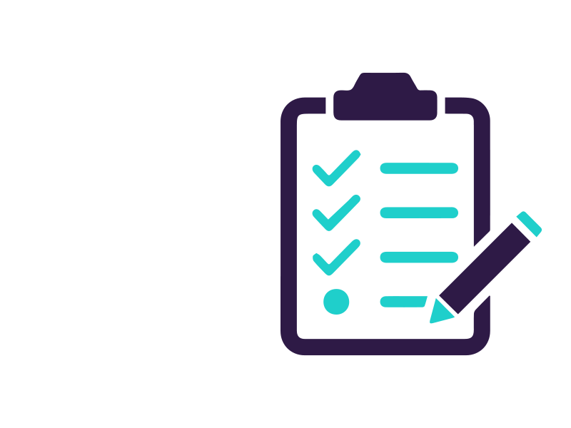  What do we use your information for? | What type of information do we use? | What reason do we have to use it (this is the boring legal bit…)
To make sure your membership with us runs smoothly and we can provide the very best service for you. | All contact and membership details, any chats we have had and your likes and dislikes. | We need all this information to make sure we do a good job in managing your membership with us.
To provide you with merchandise or other services/ products you have ordered from us. | All contact and membership details.  Your parent/guardian’s payment information. | We need all this information to make sure you get the [merchandise/products/services] you ordered.
To send you information which we think you might like based on the type of membership account you have with us such as details about ticket sales, competitions and events we are running, offers and discounts and any updates on hockey. | All contact and membership details. | We need all this information to make sure we do a good job in managing your membership with us.
To send you other information we think you might like or which you have asked us to send to you. | All contact and membership details and your likes and dislikes. | Only where you have told us you want to receive this type of information.  If you are under the age of 13 your parent or guardian must have given their consent to allow us to send you marketing messages.
To help you if you have a question or you are not happy with something we have done. | Contact details and any chats we have had. | It is in our interests to make sure we deal with any issues you have quickly.
We will keep all of your details on our files. | All of your personal details. | It is in our interests to hold your details on file so we can deal with any issues with your membership and to make sure we do a good job in managing your membership. Sometimes we may have to keep your details because the law tells us we have to.  If we use any ‘special information’, we will only do so on the basis of one of the ‘special reasons' we talked about above.
To protect our IT systems. | Details about how you use our website. | It is in our interests to make sure that our IT systems are safe and secure for all of our staff and you to use.
We occasionally carry out research on what events you have attended to understand what is 'on trend'. | Details of the events and competitions you have attended. | It is in our interests to make sure that our membership is targeted and relevant for you.
To promote the sport, our events and membership packages. | Any photos or videos of you. | Only where you have told us you are happy to use our photos.
To make sure we are keeping up with health and safety. | Details of the events and competitions you have attended. | It is in our interests to make sure we provide you and others like you with a safe place to play your sport.  Sometimes we may have to keep your details because the law tells us we have to.
To register you on to and keep track of any events and competitions you attend. | Details about your performance (but we won't use any 'special information') and the events or competitions you have attended. | We need all this information to make sure we do a good job in managing your development through the performance programme.
We will use your details to assess your performance and to find out what else we can do to help you improve your development and training with us. | Details about your performance and the events or competitions you have attended.  We might also hold details about your health and any club or county membership. | We need all this information to make sure we do a good job in managing your development through the performance programme.  If we use any information about your health, we will only do so on the basis of one of the ‘special reasons' we talked about above.
To arrange for any trip or transportation to and from an event. | Any ID cards or passport information you give us, details of family members and emergency contacts, your parent/guardian’s payment information and details about your health. | We need all this information to make sure we can make arrangements for any trip you go on.  If we use any ‘special information’, we will only do so on the basis of one of the ‘special reasons' we talked about above.
We might use details about your health (including any injuries or disability) to make sure you are playing in a safe environment by making changes to the design of our sports facilities and to ensure you are well enough to participate. | Details about your health. | We will only use this ‘special information’, on the basis of one of the ‘special reasons' we talked about above.
To put together all the information we need in case there are any disciplinary or other issues with your membership. | All of your personal details. | It is in our interests to make sure we provide you and others like you with a safe and fair place to play your sport.  If we use any ‘special information’, we will only do so on the basis of one of the ‘special reasons' we talked about above.
To make sure we are fairly offering opportunities to everyone. | Name, your birthday, gender, information which part of the world you or your family are from, details about your health and performance. | It is in our interests to make sure we provide you and others like you with the same opportunity to get into sport no matter who you are and where you come from  If we use any ‘special information’, we will only do so on the basis of one of the ‘special reasons' we talked about above.
In some cases we might need the information you have given us to make sure we can do what we say we are going to do with your details. Other times, we may not need it, but if we don’t have it, we may not be able to provide you with the best possible service.
If you have told us we can use your information in a certain way, you can tell us to stop using it at any time, by contacting us.

- HOW CAN YOU STOP US FROM MARKETING TO YOU?
Sometimes we may wish to contact you by email, post or text message to tell you about things we think you might like. We will only do this if you have told us you are happy to receive these messages and you can tell us to stop at any time by letting us know Also look out for the link at the bottom of any messages we send you which will also put a stop to any messages.

- Who else may use your details?
We may send your details to others to help us run our organisation. These are:
  - Anyone you have said you are happy for us to send your details to.
  - To any regional or governing body: to help us to improve and keep an eye on developments in the sport.
  - Organisations that provide services to us: such as marketing specialists, the people who carry out research for us, computer services and the guys that help to run and maintain our security cameras;
  - The Government or our regulators: where the law tells us to do so or to help them with any investigations.
  - Police, law enforcement and security services: to help them with any investigation, prevention of crime or matter of national security.
- ARE YOUR DETAILS SAFE?
We have put in place lots of security measures to make sure your details don’t go missing or get used in a way they shouldn’t be. We have a great team of people working with us who are trained to know how to use your details securely and will only use your details when and how we tell them to.
Did you know that all ‘data controllers’ based in the European Union and the UK like us are subject to laws that make sure that your personal details are safe?

- HOW LONG DO WE KEEP PERSONAL INFORMATION FOR?
We collect personal details from you for different reasons and so we might keep it for different lengths of time. For example, we might have to keep it for a long time for legal reasons, but most of the time, we will keep your details for 8 years after you last get in touch with us.
It is important to make sure that the details we hold about you is accurate and up-to-date, so make sure you let us know if anything like your email address or phone number changes. You can normally do this or by contacting us at club training.

- WHAT ARE YOUR RIGHTS?
Did you know you can ask us to do lots of things with your details?
You can ask us:
- to tell you how your details are being used;
- to provide you with a copy of all details we hold on you;
- to correct some of the details we hold if they are not correct or out of date like your contact details for example;
- to delete all of the details we hold on you (unless we have a good reason not to!);
- to stop using your details in a certain way;
- to send your details to you or another organisation like any club you play at for example; and
- [to stop making decisions about you using automated technologies which analyse your personal details e.g. performance software]
Some of the rights may not always apply to the personal details we hold for you as there are sometimes requirements and exemptions attached which means we need to hold on to certain information and other times the rights may not apply at all.
DON’T FORGET though, if you have told us we can use your information in a certain way and you would like us to stop, you can tell us to stop at any time and you can always tell us to stop sending you marketing messages. More information about these rights can be found online here https://ico.org.uk/for-the-public/. If you have any questions or are unhappy about something, please contact us at chairman@louthhockeyclub.co.uk

- WHAT HAPPENS IF WE NEED TO CHANGE THIS NOTICE?
Keep an eye out for changes to this notice online. If we make big changes the version date at the bottom of the notice will be updated. Of course where we are required to do so by law, we will ask for your permission before we change the reason for using your details.

- HOW CAN YOU GET IN TOUCH?
If you have a question or a complaint, you can always get in touch with one of our team The Pavilion. London Road, Louth, LN11 9QP. If you have any questions or concerns please contact one of our welfare officers: Richard Hill, Amie Wright or Emily Wood either in person or via email: welfare@louthhockeyclub.co.uk

Version dated 15th August 2022

